Ringer Manager

Abstract - A context-aware application which decides the ringer mode of user’s mobile based on user’s location, neighbors, the noise level of the location, and a relationship of the user with the caller. For e.g. If a user is getting an urgent call, then ringer application is committed to change the ringer mode to loud so that user does not miss an urgent call.

Simulation – A Java Program which decides the Ringer Mode of requested call.
Steps -

0. Starting a background service to listen to neighbors calls and send them feedback based on rationale.
1. It is taking location, mode of the user, expected mode of the user as inputs.
2. Entering the Location.
3. Requesting a call from the caller.
4. Initializing the Neighbor’s List.
5.a Sending rationale also with response to provide argument in favor or in opposition to support ringer mode.
5.b Sending Response considering all the parameters e.g. Noise Level, Caller Relationship etc.
6. Storing the result into the database for future references.
7. Checking for Sanctions. If required, updating the response based on Sanctions and Caller feedback.

Step – 0 A background service has been started which will keep on listening to neighbors calls at an interval of 5 seconds. It will be doing the following two tasks.
- Get calls in current place as a neighbor.
- Send feedback based on rationale and user’s expected mode.

(a) Get calls in current place as a neighbor – This service will keep on sending the get calls request and it will keep on displaying the message on Console every 5 seconds as follow:-

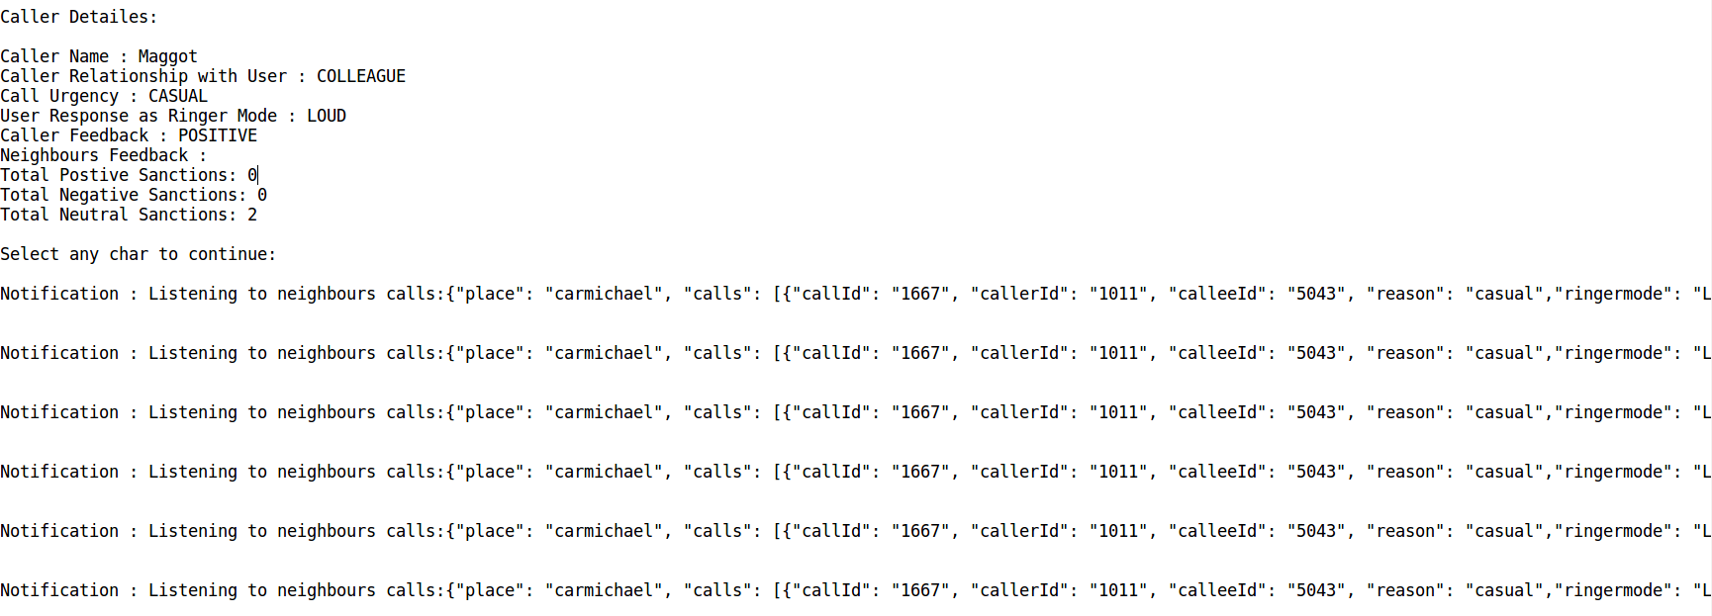

(b) Send feedback based on rationale and user’s own expected mode.
- Calculating Feedback F1 – F1 is calculated based on user’s expected mode. Suppose if user’s expected mode at hunt is vibrate and callee’s ringer mode is Loud then F1 will be negative.

- Calculating Feedback F2 – F2 is calculated based on callee’s rationale. Callee is gonna provide you arguments in favor of ringer mode.
It’s also possible that arguments are not valid with respect to ringer mode, in that case you might not wanna change your feedback.
For example – consider a scenario where callee is in meeting and he is getting an urgent call from friend and majority of expected mode is silent and callee rationale is "ArgInFav(ringermode-IS-VIBRATE+WHEN+call_reason-IS-URGENT)". Based on given rationale calculated feedback will neutral or positive because call reason is urgent.

Consider the same scenario with rationale as "ArgInFav(ringermode-IS-VIBRATE+WHEN+nois-IS-3)" then in this case F2 should be same as F1 because it’s not valid argument.

After calculating F1 and F2, the service will update the feedback with values F1 and F2 and after updation you will see following on console

Notification: {"place": "hunt", "calls": [{"callId": "1581", "callerId": "1008", "calleeId": "5043", "reason": "casual","ringermode": "Silent", "rationale": "ArgInFav(ringermode-IS-SILENT+WHEN+Majority(expected_mode)-IS-SILENT)", "feedbacks": [{"calleeId": "5043", "id": "5044", "relationship": "1", "feedback": "POSITIVE", "feedbackUpdated": "POSITIVE"}]},

{"callId": "1582", "callerId": "1007", "calleeId": "5043", "reason": "casual","ringermode": "Silent", "rationale": "ArgInFav(ringermode-IS-SILENT+WHEN+Majority(expected_mode)-IS-SILENT)", "feedbacks": [{"calleeId": "5043", "id": "5044", "relationship": "1", "feedback": "POSITIVE", "feedbackUpdated": "POSITIVE"}]},

{"callId": "1583", "callerId": "1007", "calleeId": "5043", "reason": "casual","ringermode": "Silent", "rationale": "ArgInFav(ringermode-IS-SILENT+WHEN+Majority(expected_mode)-IS-SILENT)", "feedbacks": [{"calleeId": "5043", "id": "5044", "relationship": "1", "feedback": "POSITIVE", "feedbackUpdated": "POSITIVE"}]},

Notifications:
Feedback sent results for call:1581, and result is:{"info": "Feedback(s) successfully set."}
Feedback sent results for call:1582, and result is:{"info": "Feedback(s) successfully set."}
Feedback sent results for call:1583, and result is:{"info": "Feedback(s) successfully set."}

These notifications will keep on coming every 5 seconds and user will continuously be performing other activities in parallel.

Step – 1 It is taking location, mode of the user, expected mode of the user as inputs.
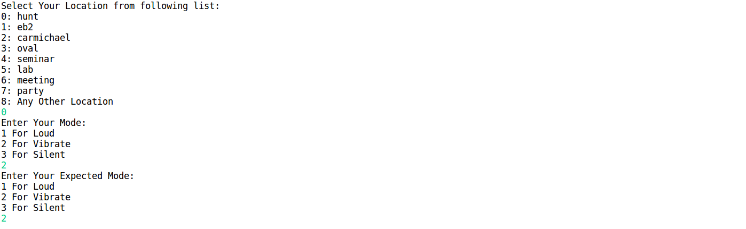

Step 2 - Entering the Location.
User will enter the location with the expected mode and the user mode taken as inputs in the first step.

Step 3 - Requesting a call from the caller.

Step 4 – Initializing the Neighbour’s List.
The User is fetching the latest neighbors data for every call as they can leave the place and different people can enter the same place.

Step 5 (a) Sending rationale with response to provide argument in favor or in opposition to support ringer mode.

A rationale is calculated based on all the parameters which is used for deciding ringer mode.
For example – If caller relationship is family and call urgency is casual then rationale would be
"ArgInFav(ringermode-IS-LOUD+WHEN+caller-relationship-IS-1)"
Similarly if noise level is high and call urgency is Urgent then rationale would be
"ArgInFav(ringermode-IS-LOUD+WHEN+caller-urgency-IS-urgent+AND+noise-IS-8)"

Step 5 (b)– Sending Response.
The Ringer application will call the social benefit function and which in turns first will check the database (introduced in next step) whether the same record is existing in the database.

For e.g. hunt,URGENT,COLLEAGUE,LOW,HIGH,LOUD

It means the place is hunt with noise level LOW and Brightness Level High and colleague is calling the user which is urgent and ringer mode is Loud.

If the record is not existing in the database then it will get added to Database so next time social benefit function simply can look to the database and return the response.
The same database will also be required for Sanctions adaptability if Caller feedback is negative or Neighbors are giving negative sanctions.

Step 6 – Data Storage

Data will be stored in following format which will be used for step 5 for next call or for Social Adaptability in case of negative Sanctions.

Now, suppose if a family member is calling the user which is urgent and the user is at hunt place having noise level low and brightness level high then social benefit function can simply return the response from following table which is LOUD (Second Row).

Place | Call Urgency | Relationship | Noise Level | Brightness Level | Ringer Mode as Response
hunt | URGENT | COLLEAGUE | LOW | HIGH | VIBRATE
hunt | URGENT | FAMILY | LOW | HIGH | LOUD
hunt | CASUAL | COLLEAGUE | LOW | HIGH | SILENT
hunt | CASUAL | FRIEND | LOW | HIGH | SILENT
hunt | URGENT | FRIEND | LOW | HIGH | LOUD
hunt | CASUAL | FAMILY | LOW | HIGH | SILENT

Step 7 - Checking for Sanctions
After sending response, the user will get response from the caller and neighbors. If caller feedback is either neutral or positive or majority of neighbors are giving neutral or positive sanctions then there is no need of updating the record in the database.

Feedback’s are recorded from two attributes -
- Feedback
- UpdatedFeedback

While deciding for adaptability, first updated feedback is checked if its null then feedback is considered as updated feedback.

___________________________________________________________________________________

Commitments
It’s depending upon following factors:

- Call Urgency
- Relationship
- Noise Level
- Brightness Level
- Neighbours

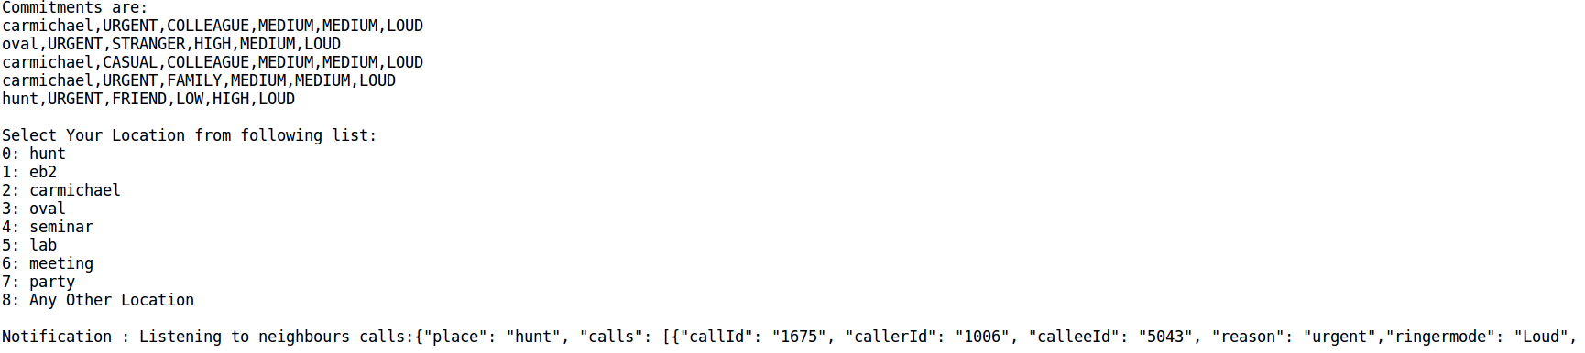

Case 1 Urgent Call – If caller relation with user is either Family or Friend then Ringer Mode will be LOUD. But if caller relation with user is either stranger or colleague then it could be either LOUD or VIBRATE depending upon Noise Level, Brightness Level, Majority of Expected Mode of Neighbors.

If Relation is either Family or Friend and Call is urgent then Ringer mode will be Loud regardless of anything. But if Relation is either Stranger or Colleague and noise level is high and brightness level is high then it will return loud otherwise Vibrate.

e.g. - Urgent Call With Friend

Caller Name : Bilbo
Caller Relationship with User : FRIEND
Call Urgency : URGENT
User Response as Ringer Mode : LOUD
Caller Feedback : POSITIVE
Neighbours Feedback :
Total Postive Sanctions: 0
Total Negative Sanctions: 9
Total Neutral Sanctions: 2

e.g. Urgent Call With STRANGER

Caller Name : Nazgul
Caller Relationship with User : STRANGER
Call Urgency : URGENT
User Response as Ringer Mode : VIBRATE
Caller Feedback : NEUTRAL
Neighbours Feedback :
Total Postive Sanctions: 3
Total Negative Sanctions: 4
Total Neutral Sanctions: 3

Adaptability to Sanctions/Caller Feedback – In a case of urgent calls, there can be conflicts between expected mode of Neighbours and Ringer Mode as the response for the caller. Preference has been given to caller in case of Urgent Call.

For e.g. in the first example where Caller Name was Bilbo and Call Urgency was Urgent, User received 9 Negative sanctions from Neighbours and 2 Neutral Sanctions. Nevertheless, User received positive feedback from caller context so ignored neighbor’s sanctions.

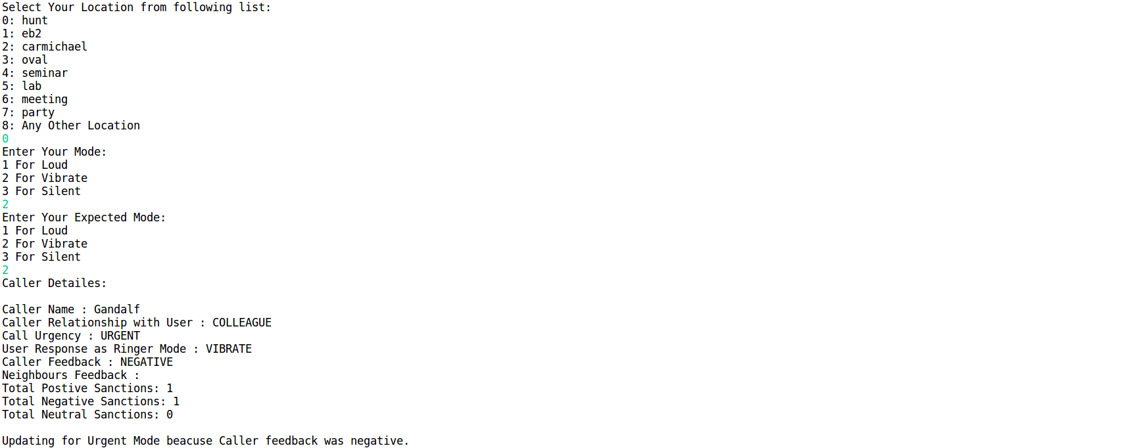

User received Urgent call from colleague and it’s Ringer response was Vibrate. But, User received negative feedback from caller so Ringer Application has to update the record in the database.

hunt,URGENT,COLLEAGUE,LOW,HIGH,VIBRATE (Updated VIBRATE to LOUD) – hunt,URGENT,COLLEAGUE,LOW,HIGH,LOUD

___________________________________________________________________________________

Case 2 Casual Call – In this case, the ringer mode is calculated based on considering all the parameters unlike first case where if the call urgency is Urgent and relationship is either family or friend then ringer mode will be Loud.

If the relationship is either Stranger or Colleague then Ringer Manager is calculating the majority of expected mode of neighbors and sending that as Response.
If the relationship is either Family or Friend then it will check for Noise Level as well as Brightness Level and then will send the response based on aforementioned parameters.

e.g.
Caller Name : Sauron
Caller Relationship with User : COLLEAGUE
Call Urgency : CASUAL
User Response as Ringer Mode : SILENT
Caller Feedback : NEUTRAL
Neighbours Feedback :
Total Postive Sanctions: 4
Total Negative Sanctions: 2
Total Neutral Sanctions: 4

hunt,CASUAL,COLLEAGUE,LOW,HIGH,SILENT

In above case majority of expected mode was silent so sent the same as ringer mode. Not considering Noise Level and Brightness Level because of relationship strength.

e.g.

Caller Name : Legolas
Caller Relationship with User : FRIEND
Call Urgency : CASUAL
User Response as Ringer Mode : VIBRATE
Caller Feedback : NEUTRAL
Neighbours Feedback :
Total Postive Sanctions: 1
Total Negative Sanctions: 0
Total Neutral Sanctions: 4

eb2,CASUAL,FRIEND,LOW,HIGH,VIBRATE

Considering majority of expected mode of neighbors, Noise Level, and Brightness level of Place.

Adaptability to Sanctions/Caller Feedback – In casual calls, Ringer Application is giving preference to Neighbor’s sanctions. If the majority of sanctions are negative then there is need of updating the record in the database. But if Majority of sanctions is either neutral or positive then check if the relationship is Family or Friend and if the relationship is either Family or Friend then check the caller feedback.
No need to check the caller feedback if the relationship is either colleague or stranger.

e.g.
Caller Name : Faramir
Caller Relationship with User : FRIEND
Call Urgency : CASUAL
User Response as Ringer Mode : SILENT
Caller Feedback : NEGATIVE
Neighbours Feedback :
Total Postive Sanctions: 5
Total Negative Sanctions: 1
Total Neutral Sanctions: 5

Updating for Casual Mode beacuse Caller(Family/Friend) feedback was negative.
hunt,CASUAL,FRIEND,LOW,HIGH,SILENT (Updated Silent to Vibrate) - hunt,CASUAL,FRIEND,LOW,HIGH,VIBRATE

If the relation in above example would have been stranger or colleague then there was no need of the updation.

Case 3 Call with No reason – Ringer Mode is decide based on the majority of expected mode of neighbors.

Adaptability to Sanctions – Caller context is not considered for these calls. If majority of sanctions is negative then there is need of updating record in database.

___________________________________________________________________________________

Place Adaptability – The user has an option to select place not enlisted in the list.
If the user want to enter the different location then he/she can select choice 8 and enter the location.

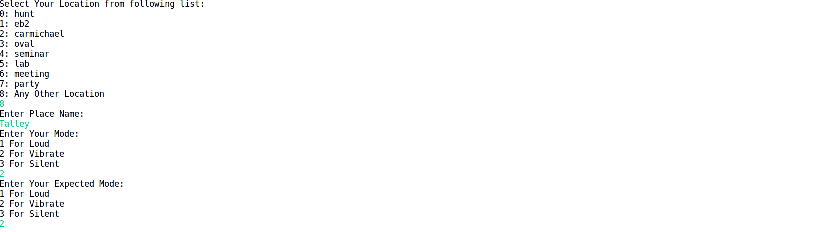
Now Talley should come in the list for next iteration.
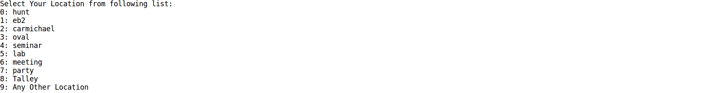

So now, the ringer application is gonna fetch all the parameters like neighbors list, noise level, brightness level for newly entered location and is gonna give response based on aforementioned parameters.

